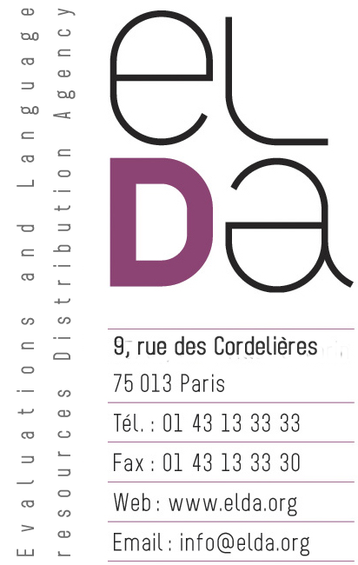

LANGUAGE RESOURCES
END-USER AGREEMENT

(Agreement Ref. No. LC/ELDA/END-USER/AURORA-SDC/2014/000/NAME)

This agreement is made by and between:

"...........................................", (hereinafter called END-USER), having its principal place of business at:

AND

ELDA S.A.S., (hereinafter called DISTRIBUTOR), the distribution agency commissioned by ELRA, having its principal place of business at: 9 rue des Cordelières - 75013 Paris, FRANCE
registered at the Tribunal de commerce de Paris:
RCS Paris B 402 781 876 (95b147 95)

Preamble:

The Aurora project was originally set up to establish a world wide standard for the feature extraction software which forms the core of the front-end of a DSR (Distributed Speech Recognition) system. ETSI formally adopted this activity as work items 007 and 008.The two work items within ETSI are:
- ETSI DES/STQ WI007: Distributed Speech Recognition - Front-End Feature Extraction Algorithm & Compression Algorithm
- ETSI DES/STQ WI008: Distributed Speech Recognition - Advanced Feature Extraction Algorithm.

This database is a subset of the SpeechDat-Car database in Spanish language which has been collected as part of the European Union funded SpeechDat-Car project. It contains isolated and connected Spanish digits spoken in the following noise and driving conditions inside a car:

- Quiet environment. Stop motor running.
- Low noise. Town traffic + low speed rough road.
- High noise: High speed good road.

whereby it is agreed as follows:

- Language Resources, object of this Agreement are described in Exhibit A.

- The site of use of the Language Resources is mentioned in Exhibit B.

- Although the database is intended to be used primarily within the AURORA project, there is no obligation to report the results.

- END-USER will not attempt to de-compile the Language Resources and will not attempt to reconstruct the raw data.

- Within this Agreement Distributor grants End-User, engaged in bona fide language engineering research, the non-exclusive right to use the Language Resources, exclusively for the purposes of their language engineering research activities.

- End-User is not permitted to reproduce the Language Resources for commercial or distribution purposes and to commercialise (or distribute for free) in any form or by any means the Language Resources or any derivative product or services based on all or a substantial part of it.

- Distributor grants End-User the right to reproduce the Language Resources temporarily or permanently, to translate, adapt, arrange and modify by any means the Language Resources, if one or all of these acts are necessary to access and make the agreed use of the contents of the Language Resources. End-User is permitted to make a copy of the Language Resources for purposes of archiving only.

- Without prejudice to the other provisions, the rights referred to herein shall be non transferable to any other entity. The Language Resources shall not be transferred to or accessed from any other site.

- End-User acquires no ownership, rights or title in all or any parts of the Language Resources.

- Distributor and the AURORA Consortium accept no responsibility for the accuracy or completeness of the data or for the consequences of their use. DISTRIBUTOR and the AURORA Consortium give no warranty for merchantability and/or fitness for a particular purpose of the LRs.

- End-User shall give appropriate references to Distributor or the AURORA Consortium, as well as to the name and reference of the Language Resources, in scholarly literature when the Language Resources are mentioned. The following acknowledgement is required: “ELRA catalogue (http://catalog.elra.info), AURORA Project database - Subset of SpeechDat-Car - Spanish database, catalogue reference: AURORA/CD0003-02”

- End-User shall not use the name of Distributor and the AURORA Consortium in any publication in any manner that would imply an endorsement of End-User or any product or service offered by End-User.

- END-USER has no right or authority to incur, assume or create, in writing or otherwise, any warranty, liability or other obligation of any kind, express or implied, in the name of or on behalf of DISTRIBUTOR, it being intended that each party shall remain an independent contractor responsible for its own actions.

- Neither party shall be responsible for damages caused by the other party's non-fulfillment of provisions of this AGREEMENT.

- Both parties exclude all liability of whatsoever nature for direct, consequential or indirect loss or damage suffered by the other.

- END-USER agrees to pay DISTRIBUTOR a compensation. The mode of payment and schedule of payments are incorporated in Exhibit C and form part of this AGREEMENT.

- This Agreement is subject to, construed and interpreted in accordance with the Law of France. Should it not be possible to settle amicably differences of interpretation out of this Agreement, then the case shall be brought before the regular courts of law for a decision. The "Tribunal de commerce de Paris" shall be the only competent court.

The entire Agreement is composed of the 17 articles herein together with Exhibits A, B, and C thereafter.

In witness whereof, intending to be bound, the parties hereto have executed this AGREEMENT by their duly authorised officers.

AUTHORISED BINDING SIGNATURES:

________________ ________________
On behalf of On behalf of ELDA
Name: Name: Khalid CHOUKRI
Position: Position: Managing Director
Date: Date:

EXHIBITS

Exhibit A Language Resources refer to:

The CD set consists of the Spanish Database, Subset of SpeechDat-Car, Aurora Project Database
Catalogue reference: AURORA/CD0003-02
Name: AURORA Project database - Subset of SpeechDat-Car - Spanish database

Exhibit B SITE OF USE:

< TO BE SPECIFIED >

EXHIBIT C Compensation:

Price for research use by academic organisations: € 200.
Price for research use by commercial organisations: € 1000.

